

**Final Project Report**

**2021 CS- 546-A**

**STEVENS MARKETPLACE**

**Web Programming- 1**

**Stevens Institute of Technology**

**Aditya Jayadevan Menon - 10473852**

**Balakishore Kongara - 10478698**

**Yash Gandhi - 10468242**

**YuFu Liao - 10478967**

**Venkat Sai Kusumurthy - 10475587**

Introduction:

This website acts as a Marketplace for Stevens Institute of Technology. People at Stevens Institute of Technology will be able to buy and sell the commodities of their wish. Users who want to sell the items will be able to post them on the site, and other users will be able to view the posted commodities and buy them if interested.

This application mainly helps students at Stevens Institute of Technology. A considerable percentage of students rely on unknown sellers to buy the commodities, and this application allows students to overcome this disadvantage. Additionally, numerous students are graduating every year, and new students join Steven’s; this application might help pass out students to sell the commodities and incoming students to buy them.

CoreFeatures:

**1.** **Landing page**: This page explains the purposes of this application, and users will login here and register with Stevens education email address.

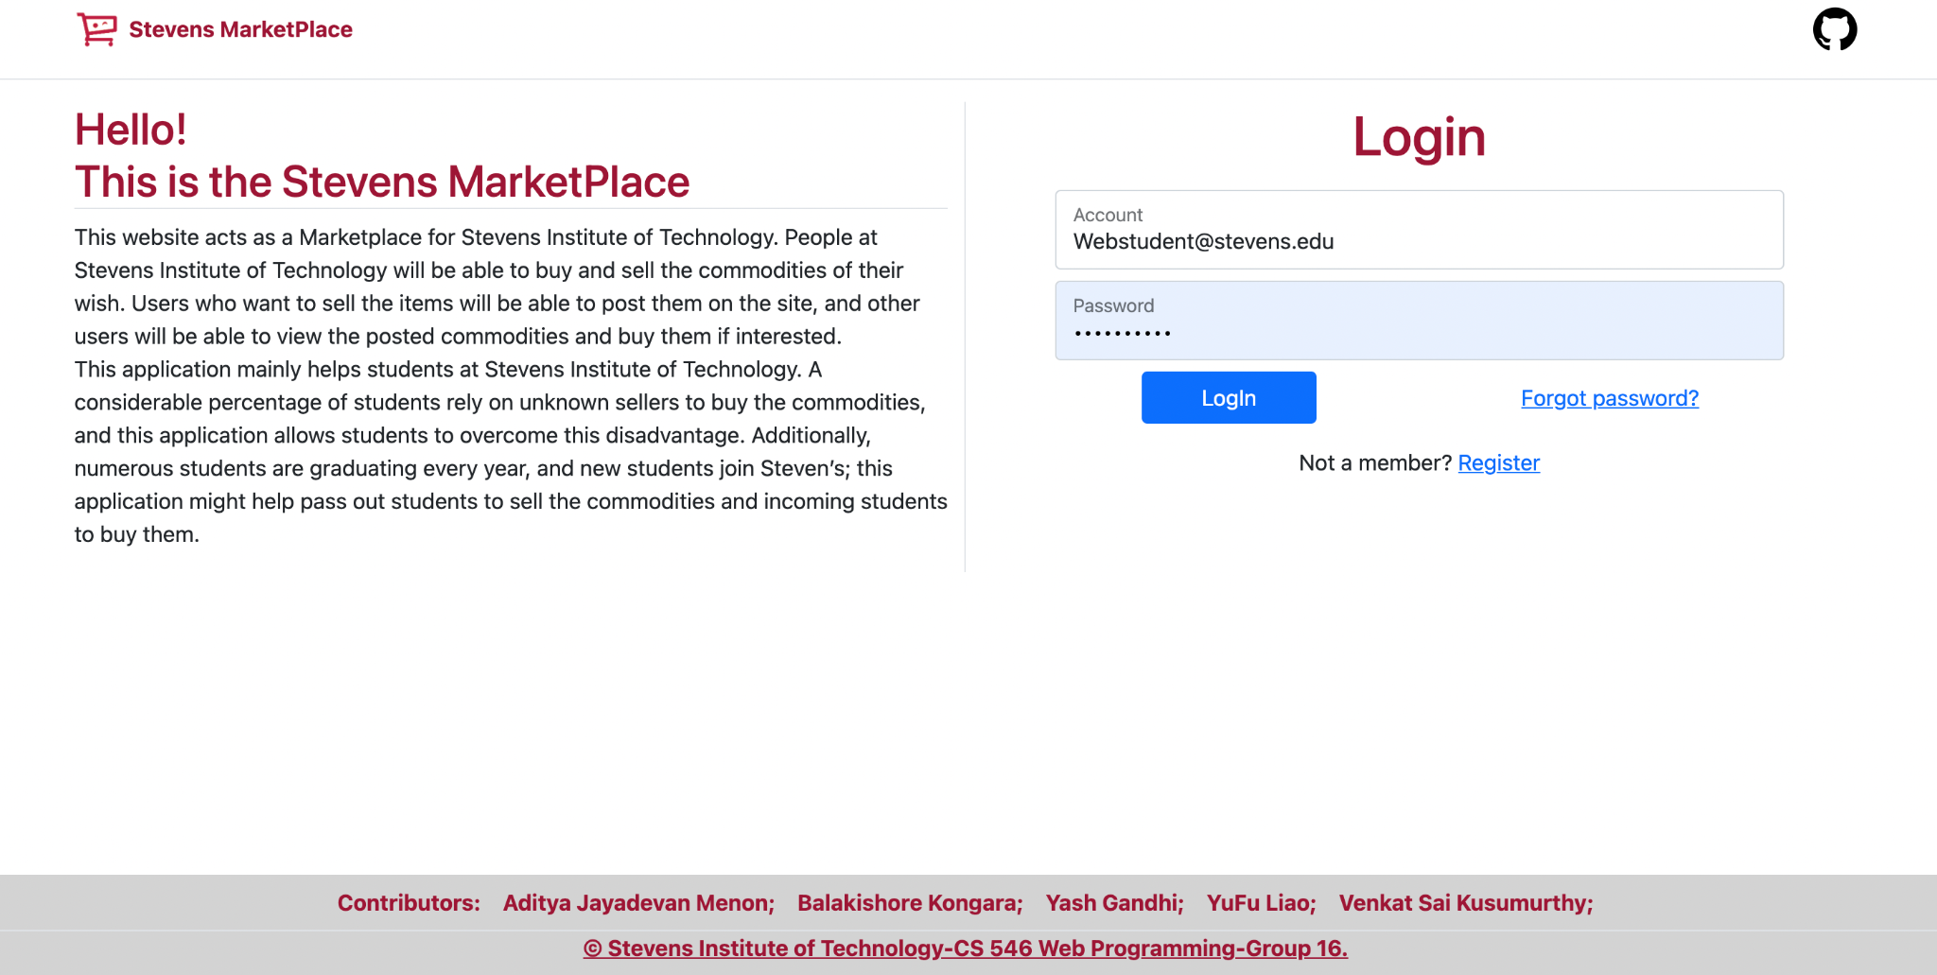

**Account -** The user enters an email-id which is assigned by Stevens Institute Of Technology. As this marketplace is only for Steven’s community, users without Steven's associated mail-id will not be able to sign up.

**Password -** The user should create a password of a minimum of 10 characters. The password must include at least one uppercase, one lowercase, one special character, and one number.

If the user is not satisfying these conditions, then the user might not be able to sign up.

**2**. **Main page**: After the users log in, the main page will show the recently published items, get notifications from other users, access to their account profile.

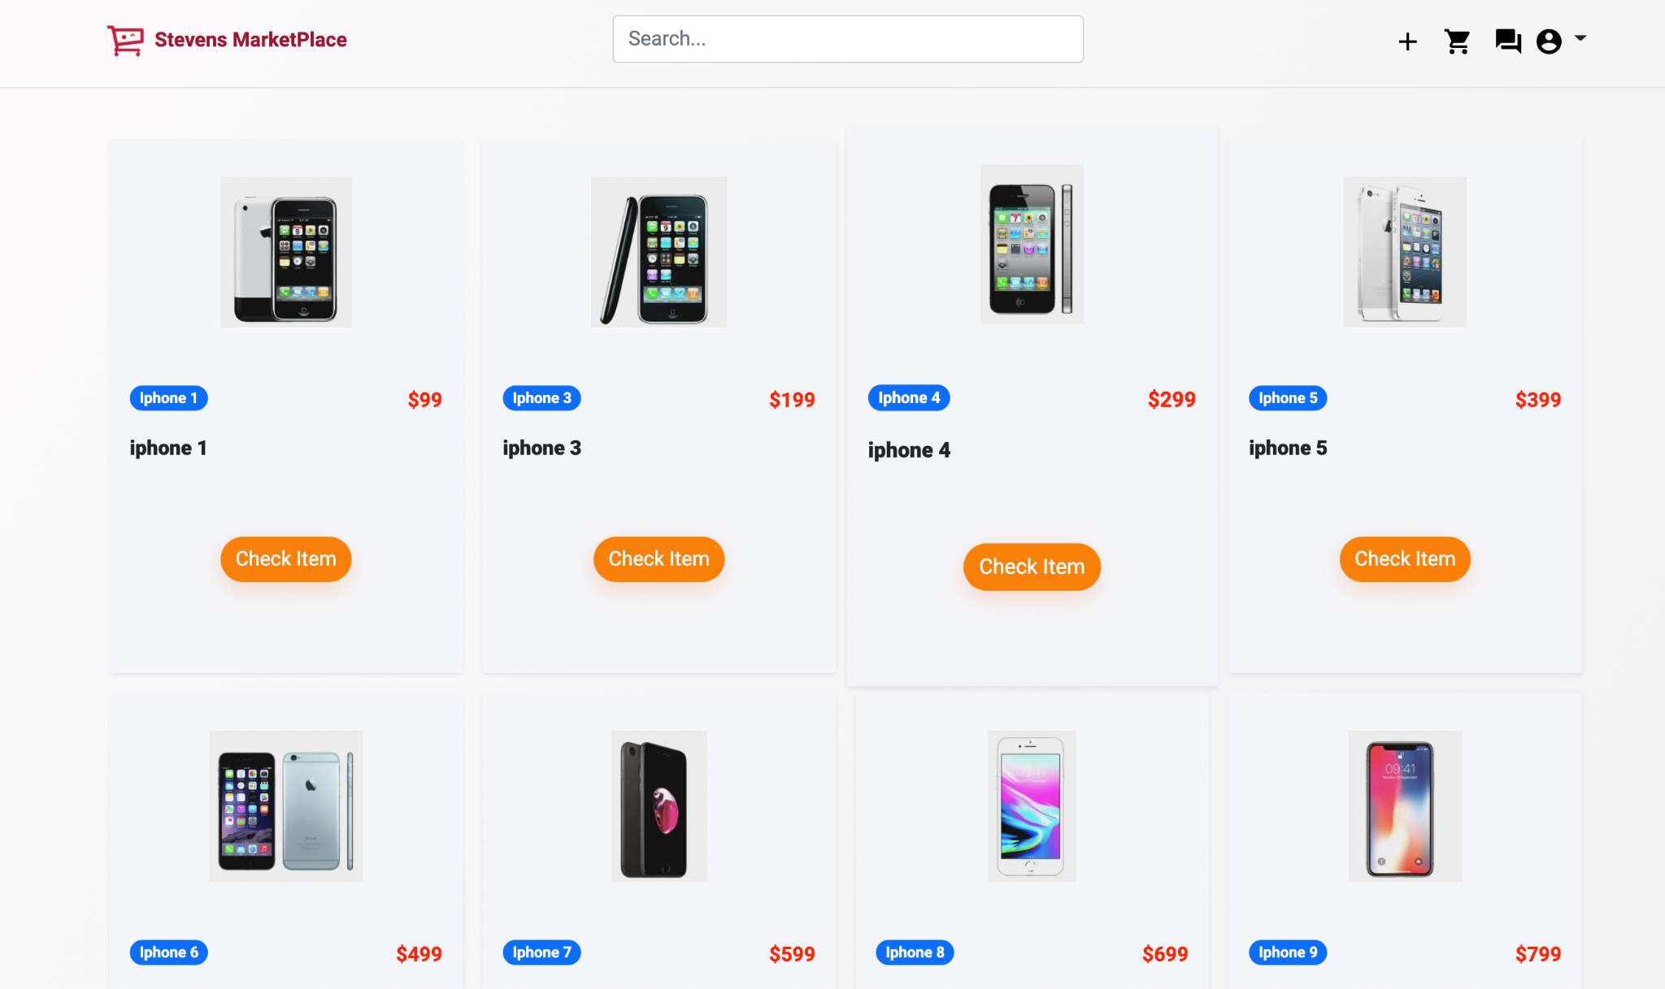

**3. View Items**: Users can view items’ descriptions, view the id of the seller, post the comments to the item or read the comments posted. Additionally, if the user likes to purchase the item, then the user can click on Buy Now, this will redirect to the transaction page, where the user can purchase or the user can add this item to the cart by clicking on Add Cart and this will redirect to cart page.

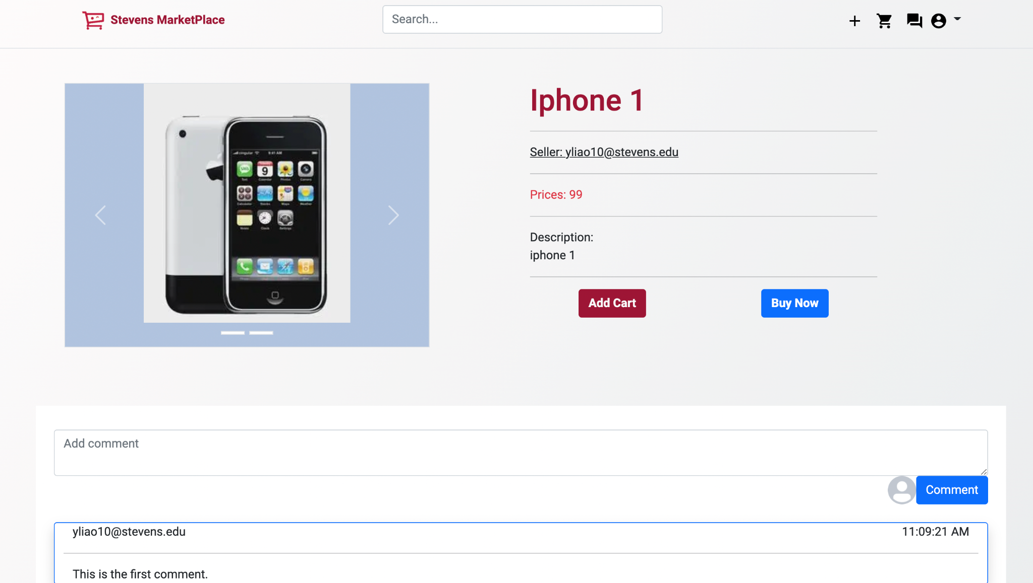

**4. Comment items**: Users can comment on an item, and other users can interact with them.

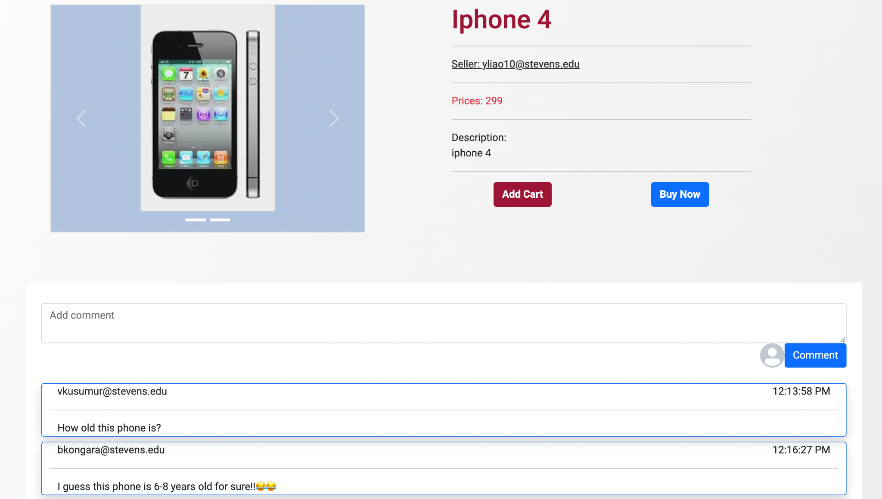

**5**. **Sell Page**: In this page the seller can view items they have sold or are currently for sale and update or withdraw the item which he is willing to sell.

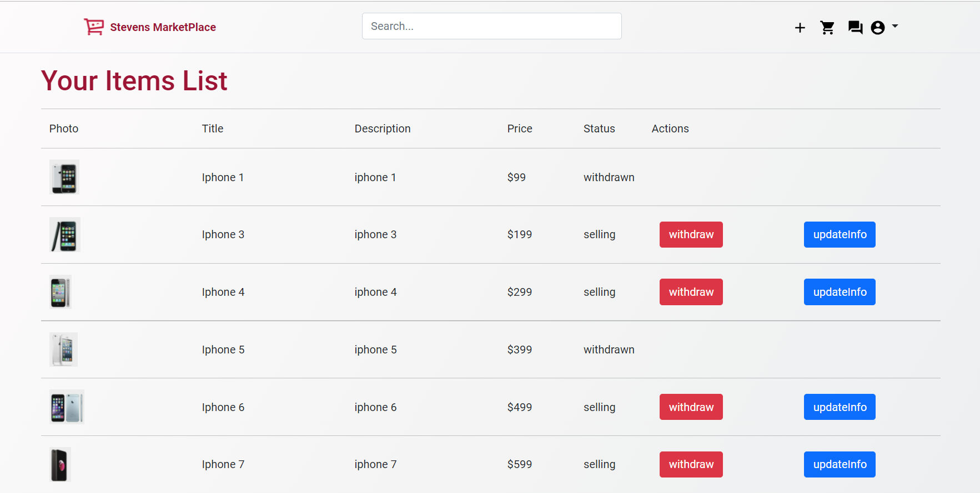

**6. Cart page**: Buyers can add items they are interested in into their carts, edit their cart, purchase particular items.

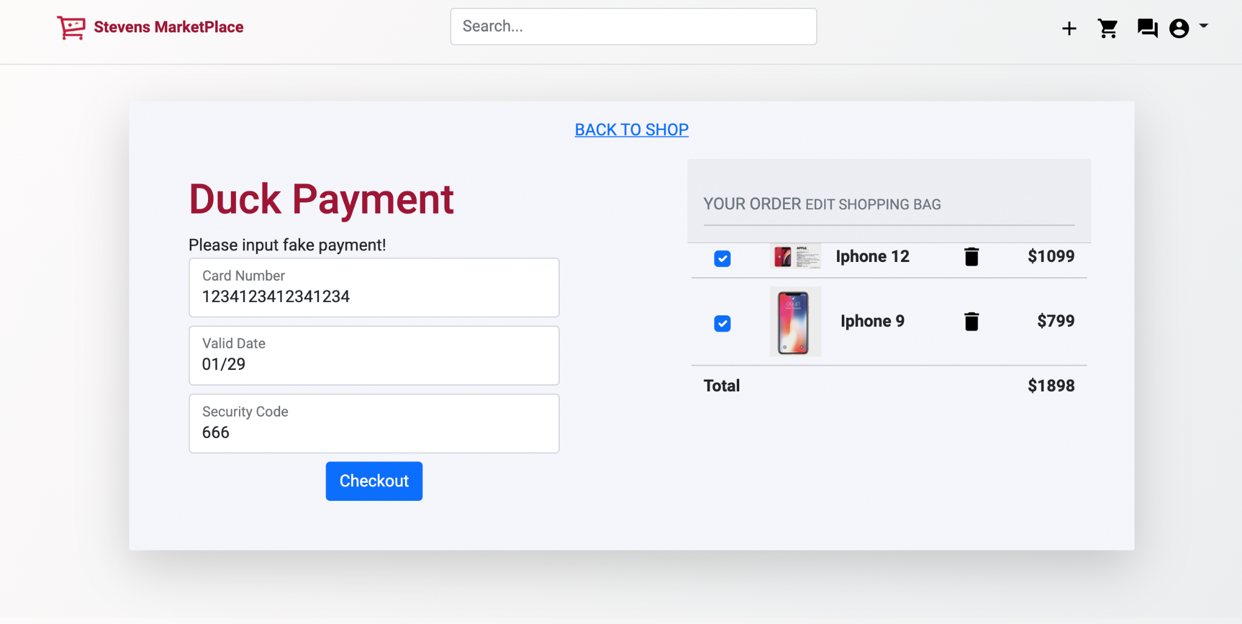

7. **Transactions**: Users can see items that they purchased, and view the details of transactions such as time and price.

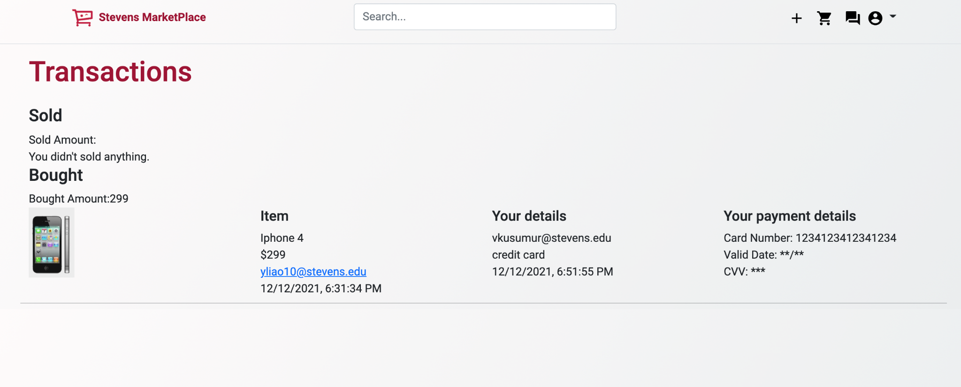

**8. Message** - The message feature allows the signed-in user to communicate with the other user who is either selling the product or purchasing the product.

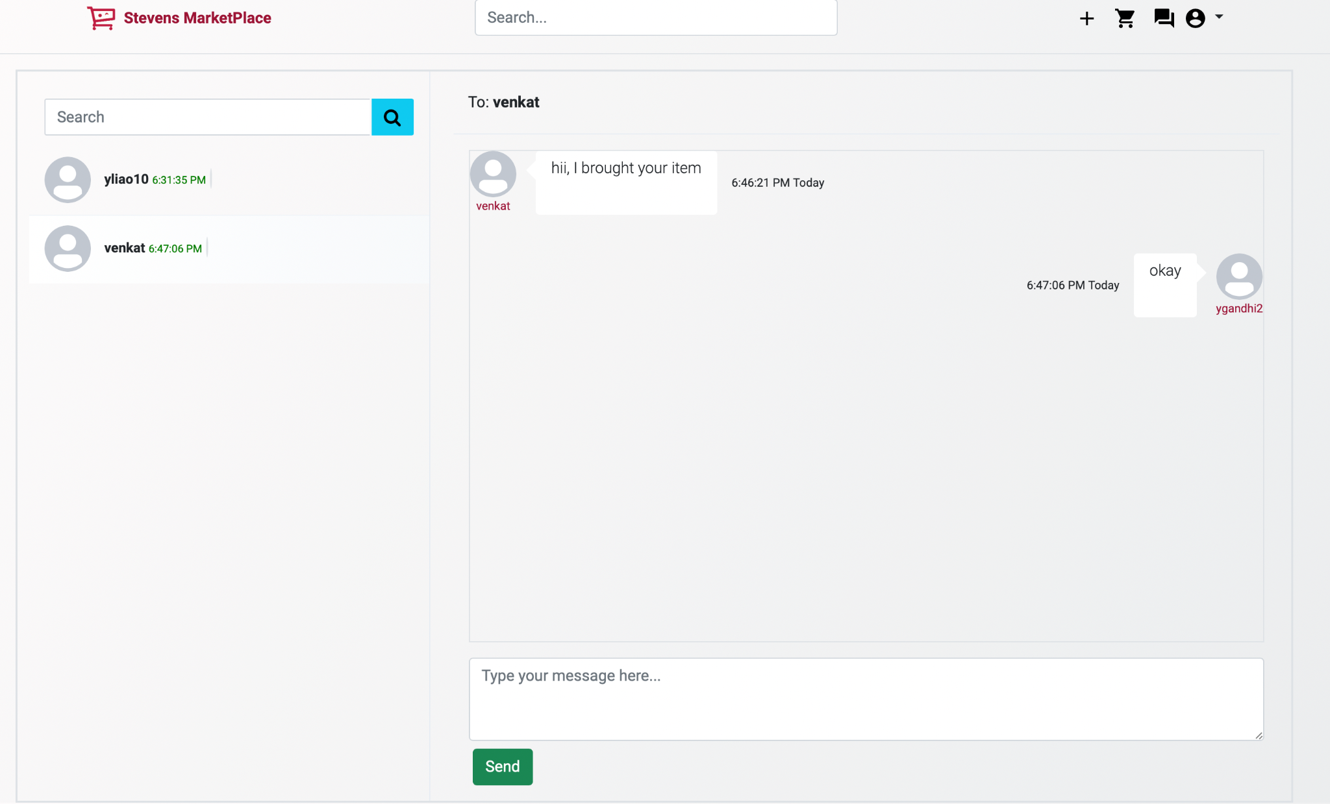

**EXTRA-FEATURE**

**1) Payment:** Here users can make a payment by entering the card details and pay the seller online. If the information provided is valid then it will store the information in bought items list with the amount of money you paid and who the seller is.

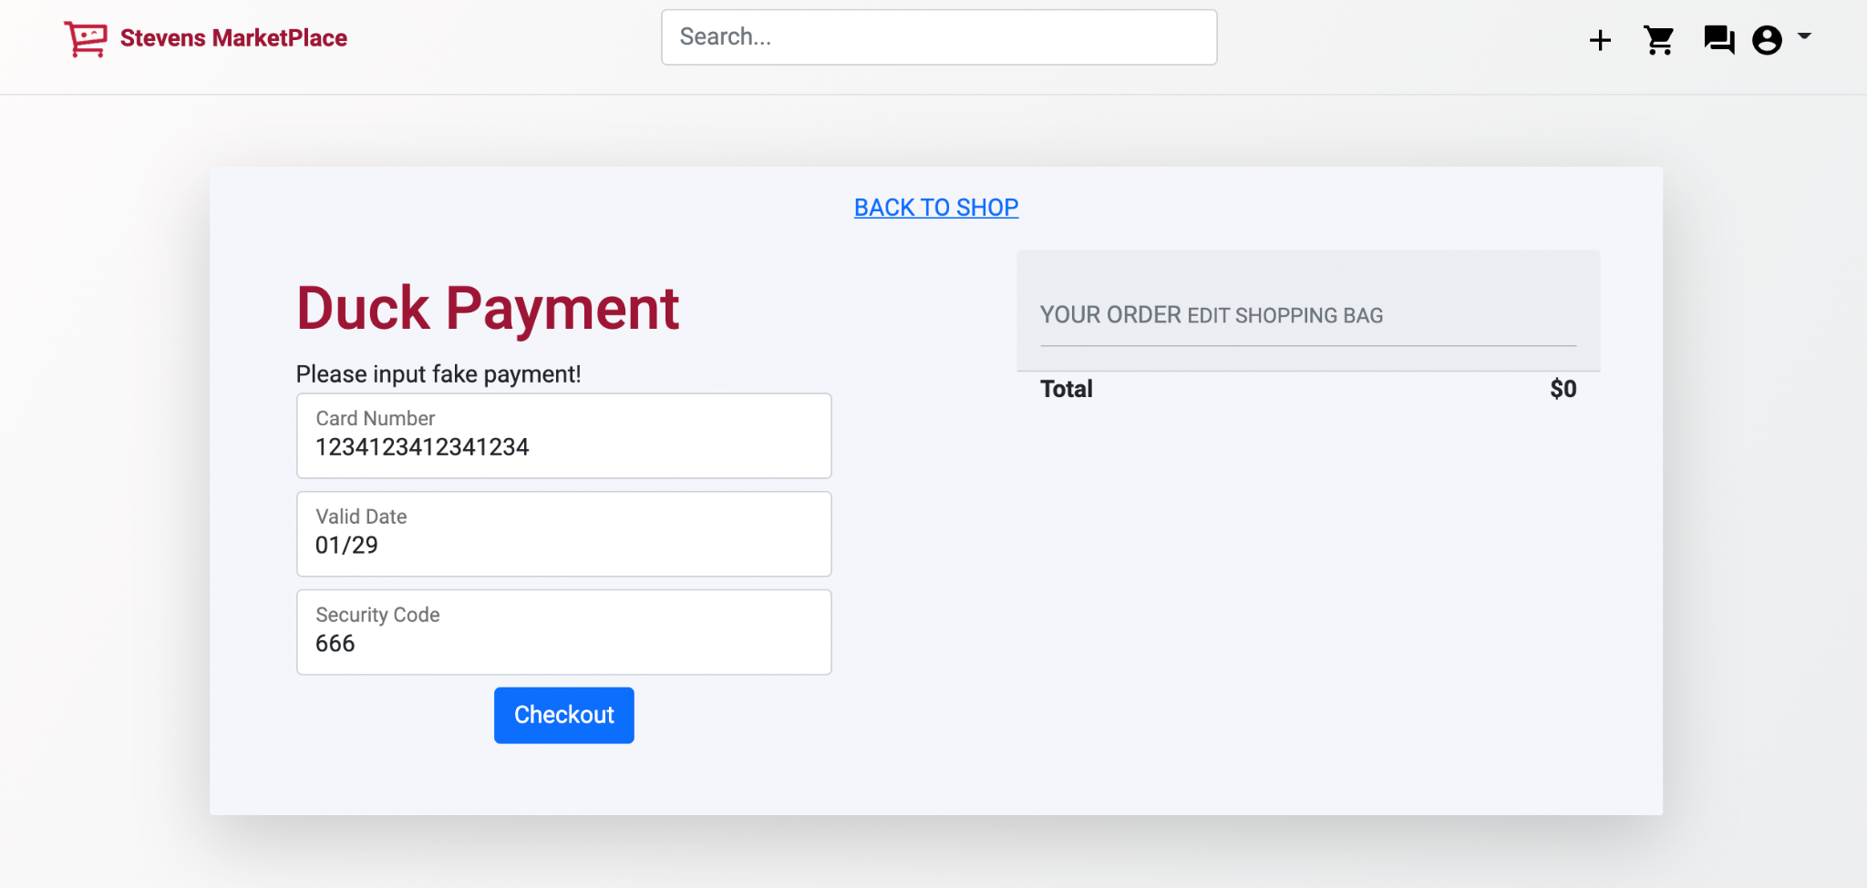

**Search-**  In the search box, users will be able to search the item/product they are looking for. This will help the users to search for a specific item/product.

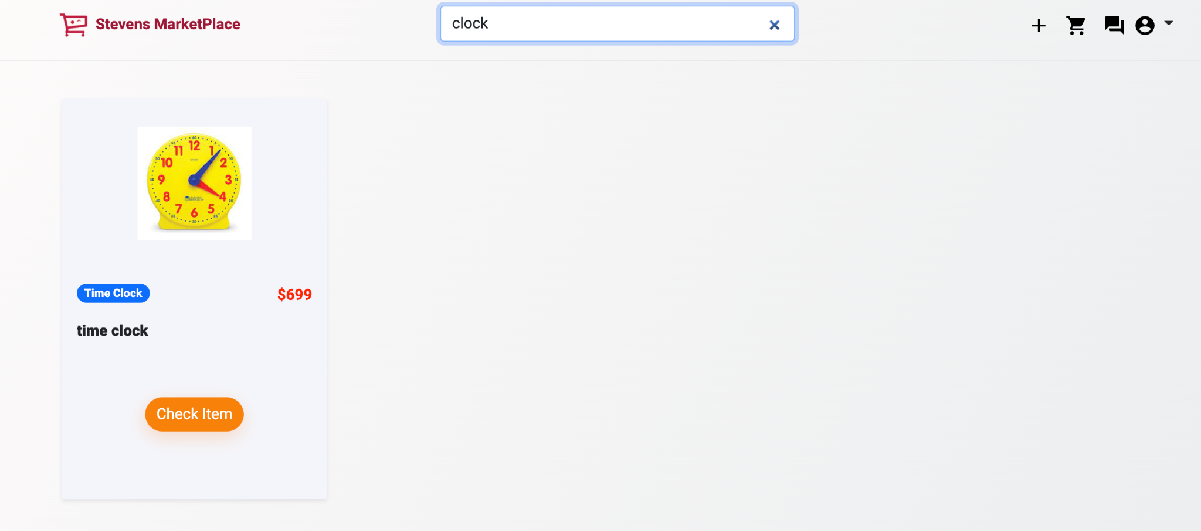

**+ -** This feature will allow the signed-in user to add the item/product to sell.

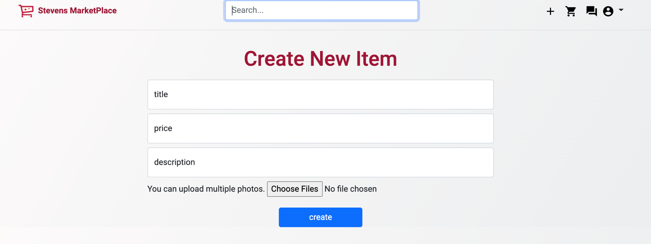

**User -** The user details have

1. **My profile**: My profile gives all the details of the user( Account, Gender, and Address ). The user can modify or update the details as per requirement.

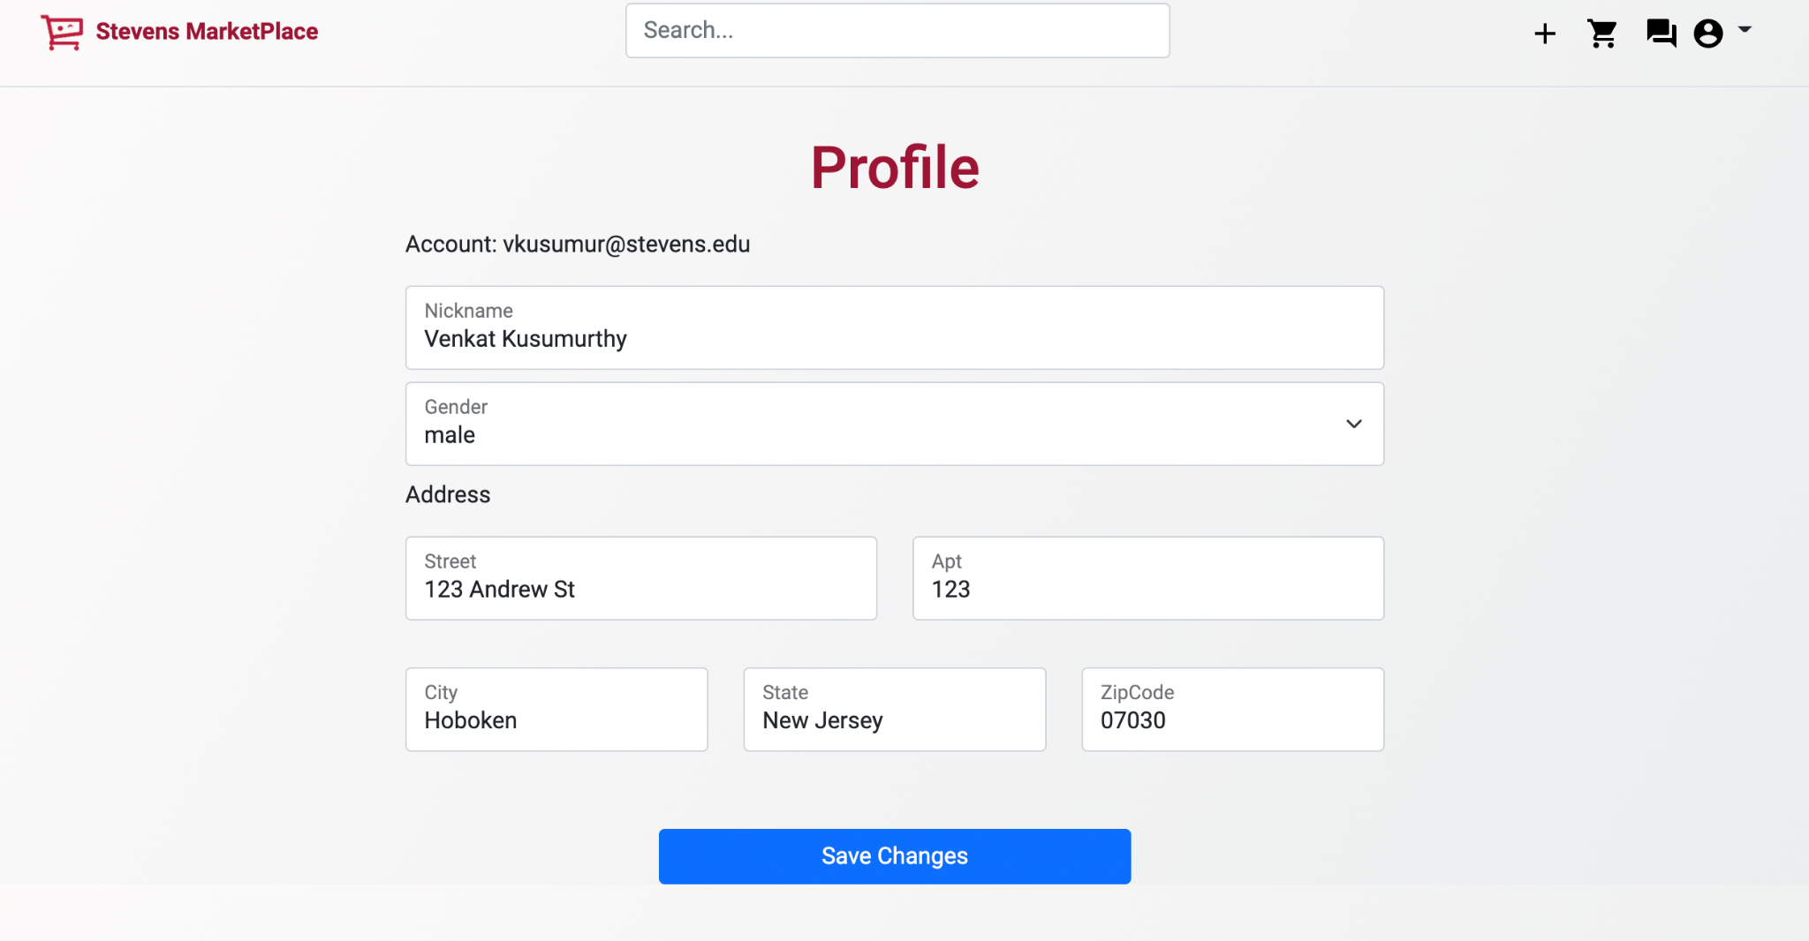

1. **My Items**: My items allow the signed-in user to view the items the user has posted to sell.

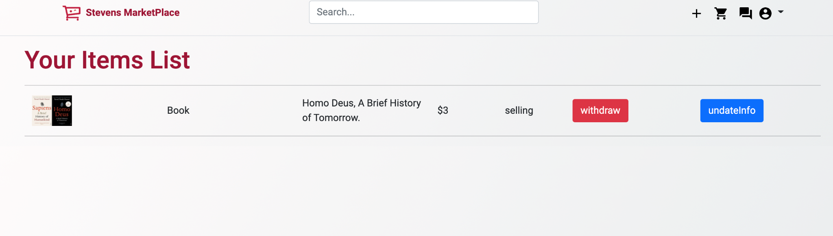

1. **My transactions**: My transactions provide all the information about the user transactions. The transaction includes the items the user has sold and items the user has brought.

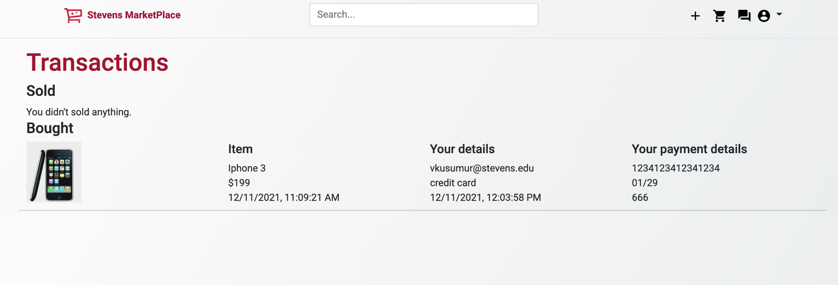

1. Sign out: Signout will allow the user to sign out of the applications and redirect to Landing Page.